Provider Name:
Type of service provided: | Respite Adaptive Childcare
Child’s Name:
Parent Name:
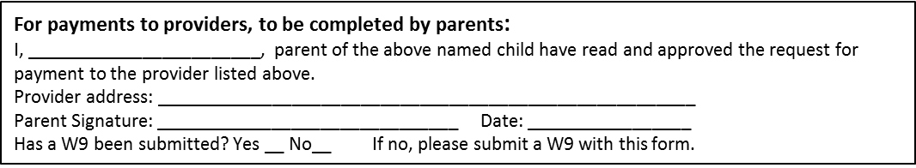

Date of Service | Start Time | End Time | Total Time | Cost per Hour | Total Cost
 |  |  |  | Total Amount:

